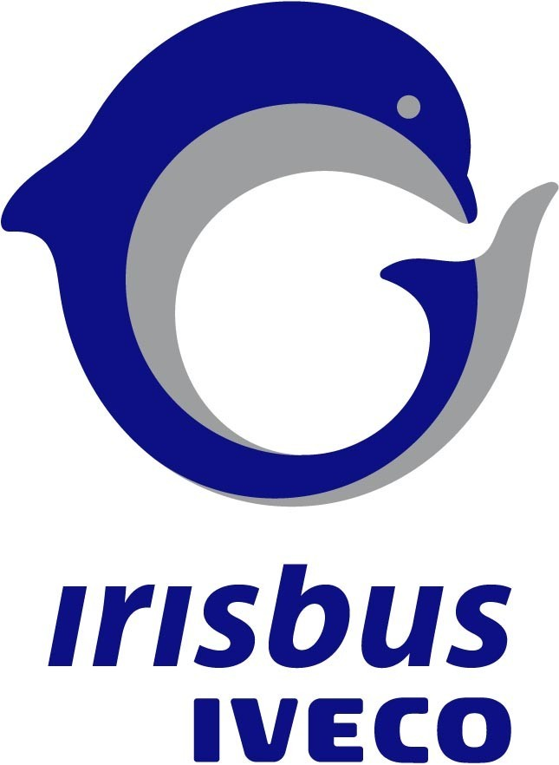

Irisbus Iveco launches Crossway, a
New Popular inter-city Coach Series

Irisbus Iveco is unveiling a new cost-effective inter-city coach named Crossway at the International Utility Vehicle Show, AUTOTEC 2006, that is being held from the 3rd to the 7th June 2006 in Brno (Czech Republic). This vehicle is more especially intended for regular short distance service, company personnel transport, etc...

Irisbus is a major player in the public transport sector at world scale and its primary ambition is to make life easier for its passengers and make their journeys safer, more comfortable and more convivial. In parallel, Irisbus aims to simplify the driver's daily tasks and offer the vehicle operator optimized profitability. So much effort that is quite naturally in keeping with a perspective of durable development, conservation of the environment and respect of the individual.

The strategy of convergence and renewal of the Irisbus Iveco ranges enters within this framework.

Crossway represents an essential stage in this strategy.

Crossway is intended for several Western European markets (Austria, Benelux, Denmark, Finland, France, Germany, Iceland, Italy and Switzerland) and all Central and Eastern European markets and it is situated between the school coach Récréo and the mixed service/excursions coach Arway in the Irisbus Iveco range.

Just like the Axer model, its predecessor, Crossway is manufactured in the Irisbus Iveco plant in Vysoké Myto in the Czech Republic.

With Crossway, Irisbus Iveco's goal is to consolidate its position as leader that it acquired several years ago at European level in the "value for money" coach segment thanks to the 900 series (presented in 1996 as a restyling of the Karosa 700 series launched in 1981). In this segment, the first choice criterion is of economic magnitude: attractive purchasing price and minimum operating cost during the entire service life of the product.

A design particular to the Irisbus family

Crossway has a modern, sober and functional profile, which places it in perfect adequacy with the requirements demanded by the operation of cost-effective transport services. As complement to the Arway coach presented at Busworld Kortrijk in October 2005, Crossway strongly asserts Irisbus's new identity, which is characterized by a smiling and expressive front end, and by a body with flowing and purified lines that make this coach something much more than a simple working tool.

This asserted style endows the most recent product of the Irisbus Iveco range with its own personality, stamped with dynamism and modernity, and marked with the sign of quality and reliability. Crossway blends in elegantly with the surrounding landscape.

The interior of Crossway reflects a harmonious balance in its very least equipment details. Ingenious associations of colours for floor carpet, side trim and roof, relook stanchions and handrails, a new roof concept and new design luggage racks mean that this coach combines conviviality with functionality and good looks with common sense.

Three lengths, two engines

Crossway is 2.55 m wide with three available lengths, offering variable capacities according to national laws and regulations, while meeting the requirements of the new European standard 2001/85 (11.5 tonnes max. rear axle load and 18 tonnes max. GVW).

The maximum capacities are as follows (with single central door):

18 tonnes GVW (2001/85) 19 tonnes GVW (France)

10.60 m² 47 seats + 21 to 24 standing places (*) 51 seats + 24 standing places (*)
12.00 m² 55 seats + 15 to 23 standing places (*) 59 seats + 26 to 29 standing places (*)

12.80 m² 59 seats + 7 to 13 standing places (*) 63 seats + 23 to 28 standing places (*)

(*) depending on options.

The seats are fastened to rails to allow layouts to be easily changed, for better modularity.

Several door configurations are proposed:
- single front door (width 800 mm) with one or two leaves.
- single central door (width 800 mm) with one or two leaves.
- double central door (width 1200 mm) with two leaves.

For the Crossway powertrain, a widely acknowledged technology, tried and tested on other vehicles of the Irisbus Iveco coach range and Iveco truck range, is used.

Recourse to numerous common technical components and standardized mechanical units corresponding to the most recent technological standards is a token of both cost-effective operation and long-term reliability.

Depending on the itineraries taken and specific operating requirements, there is a choice on Crossway between two Iveco diesel power units renowned for their reliability and performance, which have been adapted to the new emissions control standard Euro 4 (SCR, Selective Catalytic Reduction technology):

- a Tector engine combining frugality with high torque, offering two power ratings, 260 hp (190 kW) and 300 hp (220 kW), more specifically intended for flat or very slightly hilly road contours;

- a Cursor engine developing 330 hp (242 kW), which combines economy with performance and whose choice application is in situations where engine torque and power are to be privileged.

The capacity of the AdBlue reservoir is 60 litres, which allows a cruising range of some 6,000 km depending on operation.

It is to be noted that, without waiting for the arrival of the Euro 5 standard, which will be applicable in 2009, both these engines can, as option, meet the same requirements - which will not only divide the toxic emission of nitrogen oxides (NOx) practically by two compared with Euro 4, but also attain EEV (Enhanced Environmentally-friendly Vehicle) level, enabling twice as big a reduction in particulate emissions as with Euro 5.

Safety and accessibility

Owing to the rigidity of its structure, Crossway meets the requirements of regulation ECE R 66, which limits bodywork deformation in the event of vehicle tipover and provides a survival space for passengers.

Crossway has not only been developed to facilitate the frequent boarding and alighting of passengers, which are so characteristic of any line service, but also bears witness of a determination to be a coach that is accessible to everyone by meeting the recommendations of the European Union Work Group COST 349 (Cooperation in the field of Scientific and Technical Research) relative to the accessibility of wheelchairs to service coaches. For this purpose, a lift platform integrated in the central step is proposed as option (with 1200 mm double door).

Its roomy saloon, clear and luminous by virtue of an imposing glazed area, facilitates interior passenger movement (interior height: 2.28 m throughout the central aisle) and allows the installation of large-size luggage racks that complete the lockers under the floor. The total volume available for baggage thus offered is:

Crossway 10.60 m: 5.9 m³ (3.5 m³ lockers + 2.4 m³ interior luggage racks)
Crossway 12 m: 8.5 m³ (5.7 m³ lockers + 2.8 m³ interior luggage racks)
Crossway 12.80 m: 9.7 m³ (6.7 m³ lockers + 3 m³ interior luggage racks).

Its integral air suspension and its independent front wheels offer excellent driving comfort, while its reduced steering diameter (21 metres, namely a saving of 1 metre over its predecessor Axer *) provides it with driveability to ensure line service on winding roads with not particularly easy access.

The detailed technical data for the different Crossway versions are shown in the enclosed files (technical data sheets).

* comparable 12 m models

Vysoké Myto, a factory at the leading edge of production techniques

The Vysoké Myto plant, located 150 km to the East of Prague, in Bohemia, forms an integral part of the Irisbus Iveco industrial organization.

In 2005, this plant produced 1821 vehicles (of which 80% for export), a volume that ranks it as first among the six Irisbus Iveco European production sites. Let us recall the other sites, in France (Annonay and Rorthais), in Italy (Valle Ufita), in Spain (Barcelona) and in Hungary (Budapest).

In 2005, production involved 900 series coaches and buses, 10 m and 15 m Ares length versions, and the new Arway presented at Busworld Kortrijk in October 2005. Volume production of the Crossway with Tector engine is to begin in September 2006 and that of the Crossway with Cursor engine two months later.

The Vysoké Myto site was extensively modernized in 2001 with the installation of a cataphoretic E-dip plant and new painting booths. Its assembly lines and finishing lines were then reorganized and the factory now ensures high quality manufacturing, amply meeting the requirements of the standards in force in Western Europe.

The complete immersion of coach and bus bodies-in-white in a cataphoretic E-dip bath provides integral protection against corrosion. Vehicles protected in this way benefit from an increase in service life and an excellent resale value on the second-hand market – two decisive advantages for operators.

June 1st 2006

For any further information, please be kind enough to contact the Irisbus Iveco Public Relations Department:

Régine DEBERNIS Nicolas TELLIER
Phone 33 (0) 4 72 79 67 52 Phone 33 (0) 1 41 44 51 77
Fax 33 (0) 4 72 79 66 78 Fax 33 (0) 1 41 44 51 62
regine.debernis@irisbus.iveco.com nicolas.tellier@irisbus.iveco.com

IVECO IN SHORT

IVECO is a global automotive manufacturer with a fully comprehensive range of vehicles and engines specifically designed for the transport universe. IVECO undertakes to meet its customers' expectations all over the planet by making use of leading edge technologies, guaranteeing reliable performance and qualitative excellence of its products and customer service. IVECO's strategy is to generate profitable growth by concentrating on its customers and its markets and by consolidating the technological characteristics and competitiveness of its products.

Transport safety, protection of the environment and productivity on the road are the key factors of its strategy on the same score as technological innovation and a lightweight company structure.

At world scale, IVECO is in a position to supply a modern and varied range of vehicles in all the market segments. IVECO produces some 170,000 vehicles per year, which ranks the brand as one of the leaders of worldwide production. The IVECO products range from light utility vehicles, medium and heavy commercial vehicles – Daily, Eurocargo, Stralis – to construction site vehicles –Trakker –, public service vehicles, including Irisbus coaches and buses, and special vehicles (firefighting, all-terrain, defence, civil protection, etc... vehicles).

IVECO employs a workforce of 31,000 salaried workers in 48 plants located in 19 countries: in Europe of course, and in China, India, Russia, Turkey, Australia, Argentina, Brazil and South Africa. It has 15 Research and Development centres at its disposal that participate in the development of IVECO technologies and guarantee the qualitative excellence of the brand's products.

All in all, 841 dealerships and more than 4,500 approved workshops in more than 100 countries ensure the deployment of high level technical skills in all points of the globe where, at this very moment, an IVECO vehicle is on the road, or working.

